6CS030 WORKSHOP 09

Grishma lamsal

2431171

SECTION 1
- What is an ELK stack ? Explain it using its architecture.
Ans : elk stack is elastic search + logstash+kibana
Architecture:
Data sources – logstash- elasticsearch -kibana
1.logstash collects and process logs
2. elasticsearch stores and indexes data
3.kibana visualizes data using daashboards

helps organizations monitor systems, detect errors, and analyze behavior in real time

- What is Shard in ElasticSearch ?
Ans: a shard is a partition of an index
Elasticsearch splits large datasets into smaller parts called shards so it searches run faster, storage distributes across nodes are possible and scaling becomes easier
Example:
If an index has 3 shards
Index-shard1+shard2+shard3
Each shard stores part of the data

- What are the 3 major components of Logstash ?
Ans logstash pipeline has 3 stages : input (collects data), filter (process data),output (sends data somewhere)

- Perform a case study on the possible usage of ELK stack by anyone of the following companies leveraging big data.

- Netflix
netflix uses ELK for monitoring and analytics at massive scale
they use it by :
- monitoring streaming performance
- detect server failures
- analyze user activity
- track playback errors
- improve reccomendation system
workflow:
user watch
|
Logs generate
|
Logstash process logs
|
Elasticsearch stores logs
|
Kibana dashboards show performance metrics
Result: faster troubleshooting better quality.

- LinkedIn
- Medium

- Explore Fuzzy Search in ELK.
Fuzzy search finds results eevn when spelling is incorrect
For expmple :
Search : jon
Result : jhon , jonatan , jones
Useful when a user makes typing mistakes, searching similar words , matching approximate text

SECTION 2
For this, you need to install the ELK stack in your machine.

Here are some resources you can consider referring to for installation :

👉Installation link
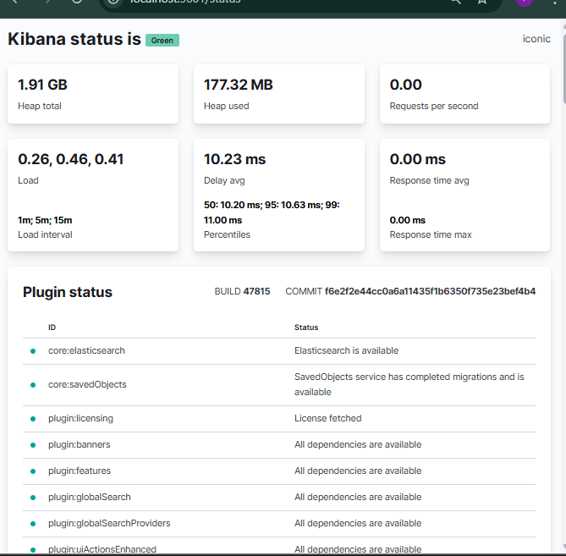
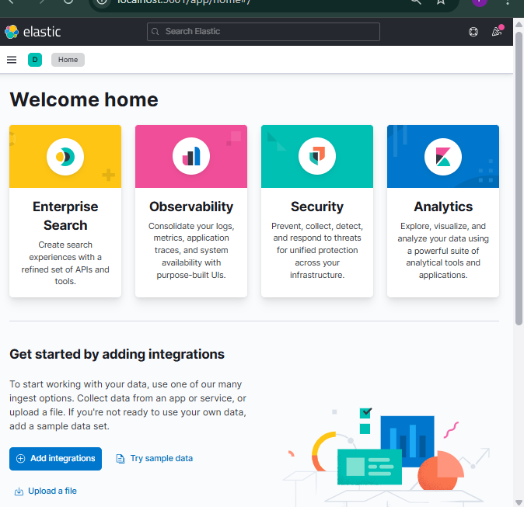
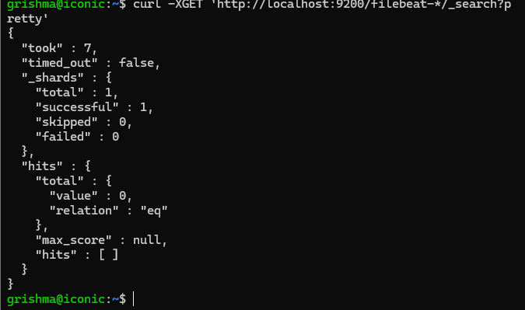

👉 ELK Stack on Windows : The Complete Installation Guide

SECTION 3
As part of building primary familiarity with ELK lets try exploring the provided elastic apis for data manipulation using the Kibana interface.

To start with this, open up Kibana on a web browser and go to :

👉 http://localhost:5601/app/dev_tools#/console

This should lead you to the Console that will allow you to kick start the task. The GUI looks like the following.

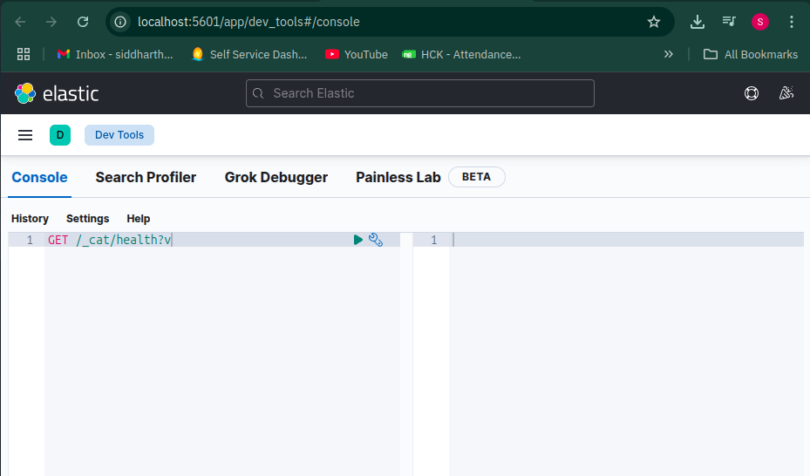

Make sure you have elasticsearch enabled too.

👉 http://localhost:9200/

If Elasticsearch is running, you should see a JSON response similar to this:

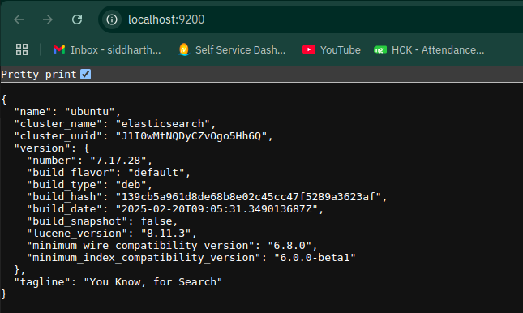

Checking Cluster Health
Your task first is to try out a way to make a cluster health check via an Elastic API call.

Consider trying the command

GET /_cat/health?v
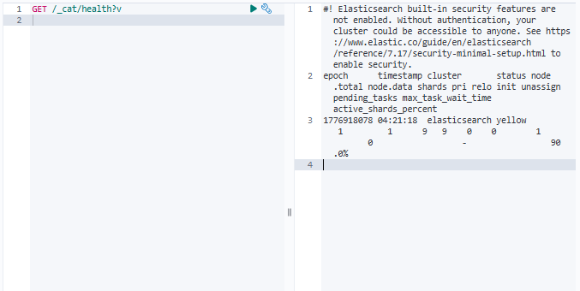

Exercise To do

- Observe and write down your understanding of the result. Also, try sending a call request without the ?v, note down the difference if present.
- Make an api call to check the node health.

Creating a Resource
Now, lets try adding in data to our nosql database which in current case is ElasticSearch.
In Elasticsearch, a resource is called an Index. Let’s create a new one using the below command :

PUT /resourcename
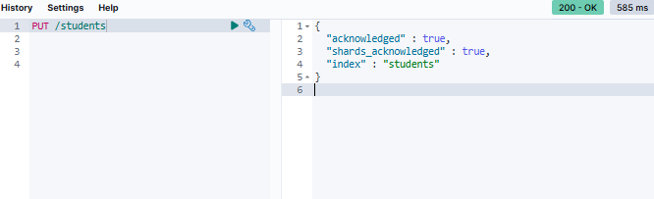

Replace resourcename with any name you want for your index (e.g.,students).

Listing Indices
Now, try out the list indices call to observe any changes in the resources using :

GET /_cat/indices
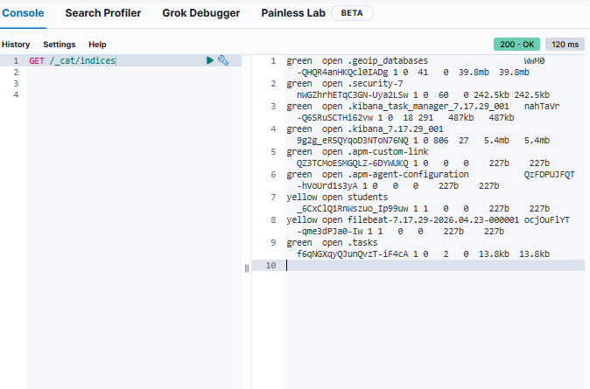

Next on, let's move ahead with addition of data into the resource we just created,

Adding Data to a Resource

PUT /students/colname/1
{
"name":"John Doe"
}
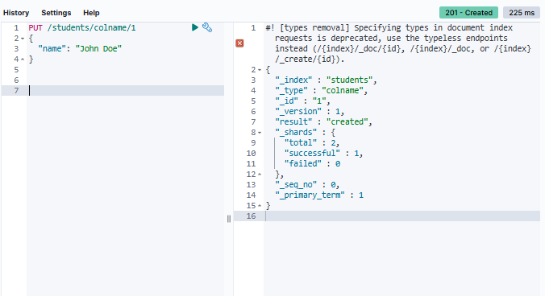

Replace :
- resourcename with your index name (e.g., students)
- colname with a type (optional in newer Elasticsearch versions, but keep it for now).
- 1 with the document ID.

Exercise To do
I helped you add John Doe, it's your turn to add in your personal data (consider populating it with your name, class group and email) to the same resource.

PUT /resourcename/colname/2
{
"name": "Your Name",
"class": "Your Class Group",
"email": "your.email@example.com"
}
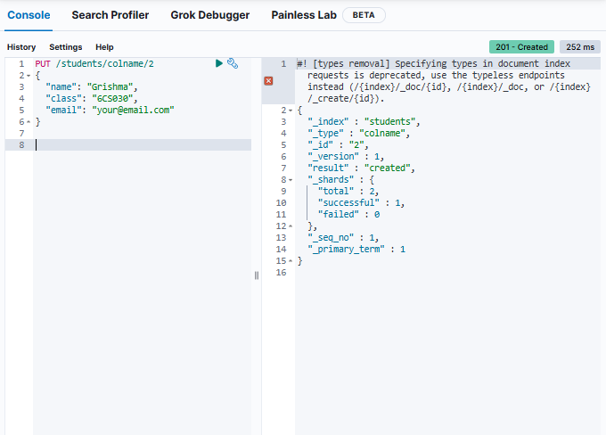

Don’t forget to replace the placeholder values with your actual details.

Fetching the Record
To view the data stored in the index, run a search query:

GET /resourcename/_search
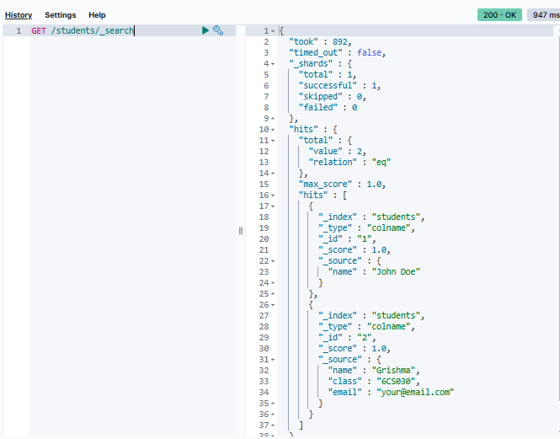

Exercise To do
- Write an api query call to fetch the second data record (that was your personal details).
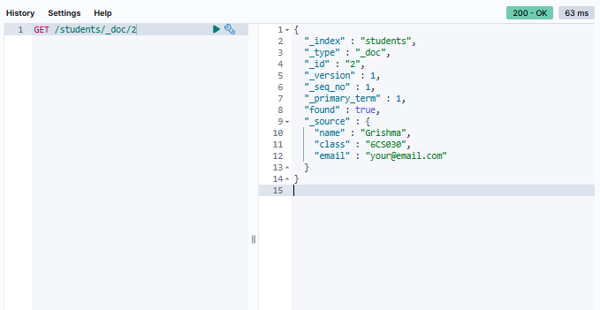
- Write a query to remove the data record of John Doe from the resource.
